RPH Tools User’s Guide

# Main Dialog Window

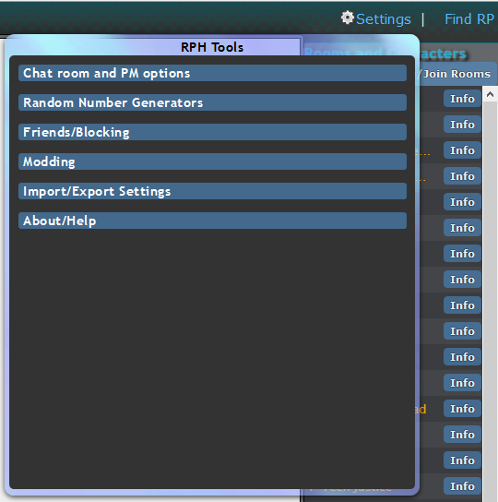

**When you click on the “Settings” link, RPH Tools opens up a dialog as shown in the figure above. Each header is a category of options to choose from. Clicking on a header will expand to reveal options. Clicking on the header again will hide the options. To close the dialog window, press the “Settings” link again.**

## Chat room and PM options

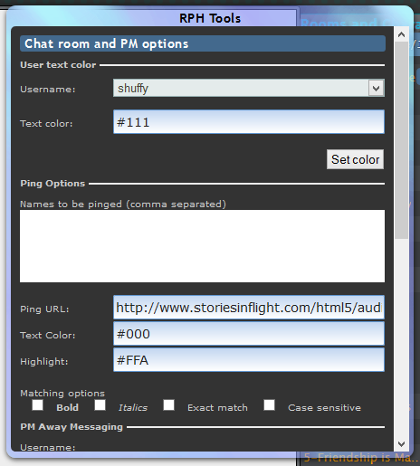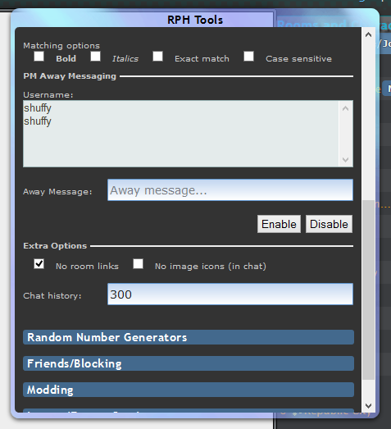

Chat room and PM options are settings that mostly affect the chat and PM system. Ping and extra options are stored on your computer after closing the dialog window. Text coloring is stored on the server.

### User text color

This changes a user’s text color in chat. To change a color:

* Select a username from the “Username” drop down list. If for some reason you do not see your username, it may be temporarily unavailable (a “zombied” name).
* Enter a hex code for the text color. This can be 3 digits or 6 digits.
  + Colors are limited to #D2D2D2 for 6 digit codes and #DDD for 3 digit codes.
* Press the “Set color” button.
  + If there is something wrong with the color, the script will highlight the “Text color” text box red.

### Ping Options

These options create a visual and audible (optional) cue when a person types up a name or phrase in which you want your attention grabbed. To set up pings:

* Enter names and phrases you want to trigger the ping. This is comma separated with no space between entries.
  + For example, do “Jon,Jane,Smith”, not “Jon, Jane, Smith”
* Enter the URL of the audio file to play when a ping is triggered. This must be a .wav, .mp3, or .ogg file.
* Enter a text color using a hex code. This can be 3 digits or 6 digits. There are no color restrictions.
* Enter a highlight color using a hex code. This can be 3 digits or 6 digits. There are no color restrictions.
* Add options.
  + **Bold** will apply bold to the text.
  + ***Italicize*** will apply italics to the text.
  + Exact Match will match the ping names if they are the word and not part of a word.
    - For example, if “Mel” is a ping name, exact matching will ping on “Mel”, but not “Melony” or “Melody”.
  + Case Sensitive will match the ping names if the letters also match the case type.
    - For example, if “Mel” is a ping name, case sensitivity will ping on “Mel”, but not “mel” or “MEl”.

You can test these settings in the chat while the RPH Tools dialog is open. To save, you must close the dialog window.

### PM Away Messaging

This sets up an “answering machine” for PMs. If someone PMs you on the name that’s considered away, the script will automatically send a pre-typed reply.

To set up PM Away Messaging:

* Select the username you want to be considered “Away”
* Enter a message in the “Away Message” field.
* Press “Enable” to mark the name as away. The name will be prepended with “[Away]”  
  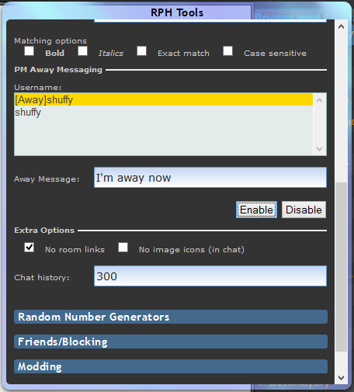
* To unmark the name as away, select the name and press “Disable”.

### Extra Options

Extra options that are useful for the chat and PMs.

* **No room links**: If RPH tags words as a room name and replaces it with a link, this will remove that link.
* **No image icons**: If a user posts an image (of about 120x120 pixels), RPH will post the picture instead of a link. This option will disable that in chat rooms.
* **Chat history**:Number of lines per chat room that the browser will show. More lines may cause performance issues.

## Random Number Generators

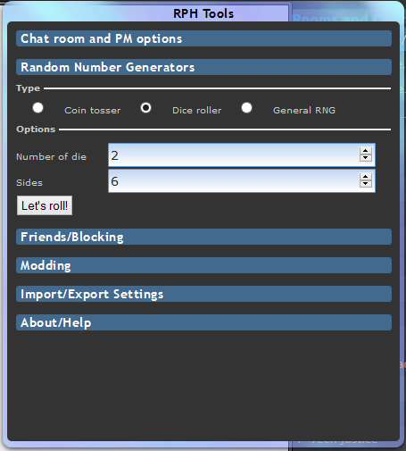

Random number generators offer three set of ways to generate a random result. The three different generators are:

* Coin toss: Flips heads or tails
* Dice roller: Flips 1-10 dice with 2-100 sides
* General RNG: Generates a number between a range

To generate the number, you must be in a chat room. Then, after selecting the generator type and inputting the values, press the button below. The script will post the result in the chat. You cannot generate another result for three seconds after that.

### Ranges for the generators

* Dice roller: Up to 10 dice may be used, between 2 and 100 sides for all of them.
* General RNG: The ranges can be set to as low as -4,294,967,296 to as high as 4,294,967,295

## Friends/Blocking

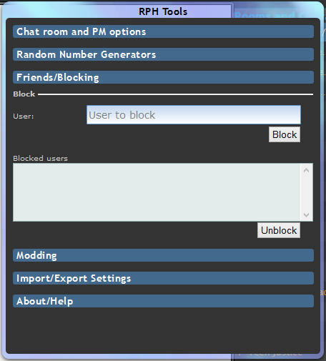

This section eases blocking of users. The script will force the “blocked” flag on other users inputted. Blocked users will be saved on your computer when the dialog closes. Blocked users will also not be aware that you’ve blocked them.

To use this:

* Enter the name in the “User” text field.
* Press the block “Button”. If the user cannot be found, the field will turn red.
* To unblock a user, select the user in the list and press the “Unblock” button.

## Modding

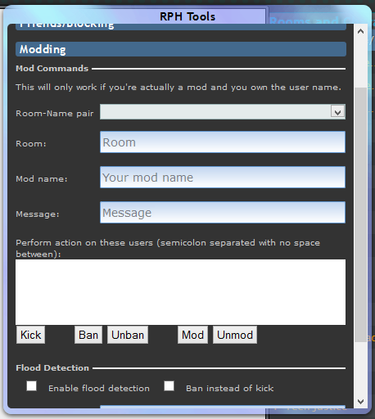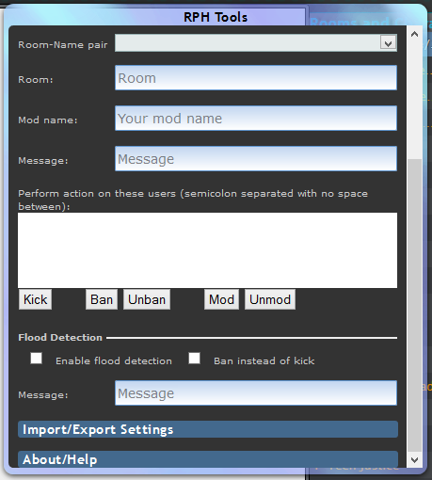

Modding eases moderation actions by allowing manual inputting of room, moderator, target users, and a message. Note that this will not work unless moderator name is owned by the account.

### Mod Commands

This section allows a moderator or owner to act upon a user in their room. To use this section:

* If the script has detected you entered a room as a moderator, it will add the room and user name in the “Room-Name pair” drop down list. This is to ease filling in the “Room” and “Mod name” text fields. Selecting a room – username pair will fill out those text fields, while selecting the very top (a blank entry), will clear them.
* Otherwise, enter the room name in the “Room” text field.
* Enter the moderator name you own in the “Mod name” text field.
* Optionally, enter a reason or other message in the “Message “field.
* In the textbox, enter the users in which you want the action performed upon. It is semicolon separated with no spaces between them. For example, use “Alice;Bob”, not “Alice; Bob”.
* Press one of the buttons to perform the action.

### Flood Detection

This is an “automatic moderator” option. When enabled, the script will monitor rooms that you have a username that’s a moderator and upon meeting certain conditions, it will perform the appropriate action. To set up:

* Check the “Enable flood detection” box if you want to turn on flood detection
* Check the “Ban instead of kick” box if you want flooders to be banned from the room instead of kicked.
* Optionally, type in a reason or message in the “Message” text field.

## Import/Export Settings

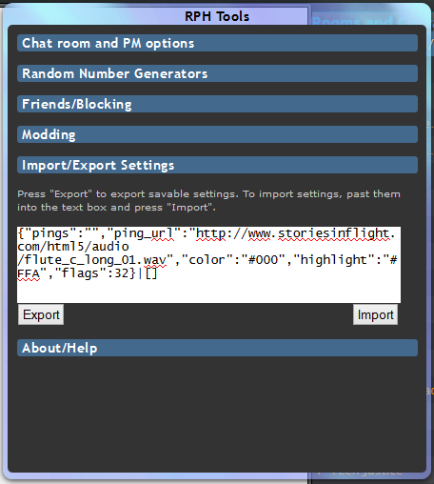

Import/Export settings will allow you to store settings that are persistent into plaintext. You can then save this into a text file for restoring settings later. To use:

* Press the “Export” button to get all the exportable settings into the text box.
  + Copy this text to save for later.
* To import settings, copy and paste saved settings into the textbox and press the “Import” button. If something is wrong with the settings, the textbox will be highlighted red.